CIS/STA 3920, 7-24-20 clarification of Question 4.2 Prof. L. Tatum
Lecture Notes 4: Classification Using k-NN

TABLE OF CONTENTS
Section Topic
1 Classification by K-Nearest Neighbors
2 Running k-NN in the Class Package of R
3 Notation for Forecasting
4 A Stock Market Application
5 Application to Forecasting Risk
LN4 Exercises

Section 1: Classification by K-Nearest Neighbors
Consider the following amusing problem in which we want to predict if an animal is a cat or a small dog based on knowing the animal’s weight and its maximum whisker length. By small dog, I mean a Mini Dachshund, Mini Poodle, or a Shih Tzu. The technical name for this type of mammalian whisker is vibrissae.
One approach would be to search the literature of comparative biology of dogs and cats with respect to weight and whisker length, if such literature exists, and develop some kind of generalized decision rule: if x > y, then “dog”, else “cat”.
Our approach will be more direct: we will ignore biology and just work with a data set containing three pieces of information about a set of animals: the first two pieces of information are the weight and whisker length for each animal, the third piece of animal is whether it is a cat and dog.
You might think it is obvious we would have that last piece of information, but to our surprise there are settings where this is not the case. We say that this problem is one of supervised learning because we know the correct classification for each animal in the sample. If we did not have the classification data, yet we were determined to try to break the animals into two or more classes based on the given measurements only, we would call the problem one of “unsupervised learning.”
This reference data set is called a training set. For each animal, the training a set includes
(a) the weight and whisker measurements;
(b) the correct classification: “cat” or “dog.”
Here is my example of a training set, with n=15:

Index | Weight | Whisker | Class
1 | 12.1 | 3.02 | Dog
2 | 7.2 | 1.50 | Cat
3 | 6.8 | 2.10 | Dog
4 | 12.2 | 3.81 | Cat
5 | 13.2 | 2.30 | Dog
6 | 11.3 | 1.90 | Dog
7 | 15.3 | 3.83 | Cat
8 | 5.3 | 1.33 | Cat
9 | 8.5 | 2.13 | Cat
10 | 9.5 | 2.38 | Cat
11 | 8.8 | 2.20 | Dog
12 | 9.1 | 1.83 | Dog
13 | 8.5 | 2.63 | Cat
14 | 9.5 | 2.38 | Cat
15 | 17.1 | 2.30 | Dog

Based on the training data, we want to make a classification prediction (or forecasts) for an additional animal, a 16th animal. This is animal we have not seen; all we know is its weight and whisker length; we don’t know if it is a cat or a dog.
There are a dozen different statistical methods by which we could attack this problem. We are going to consider a popular method called k-nearest neighbors, k-NN or KNN for short. This is considered to be one of the mainstays of “machine learning."
Here is how it works. Picture a large room in which we placed an x-y coordinate system. On the x-axis is Weight of animal; the y-axis Whisker Length of animal.
These are very well behaved animals. We lead each of the 15 animals into the room and place each animal at the point on the floor that corresponds to the coordinate given by its
(weight, whisker)
pair of (x,y) values. What could be cuter than that?
Now, we are ready to star! Our first step is to pick a value for the parameter k. A parameter of a system is a numerical constant that can be set to different values to alter the way the decision rule works, but it is not a variable, it is not like our weight and whisker variables. Let us set k=5. We soon see what that does.
Next, we are given the weight and whisker length for the 16th animal. We walk to that coordinate given by the weight and whisker of that animal, careful not step on any tails. But we stand there alone because we don’t have the animal.
Now, we look around at find the 5 nearest neighbors to where we are standing. We take a vote of them. If the majority are dogs, then we predict our 16th animal is a dog; otherwise, we forecast “cat.”
More precisely, we carefully measure the distance to all the 15 animals from that new point. We use the Pythagorean distance formula to do that; the software computes it. We then sort those 15 distances from smallest to largest, then take the first 5. Then the vote!
As an example, let us see what prediction would be made for a Test animal for which Weight = 6.8 and Whisker Length = 1.88, using k=1.
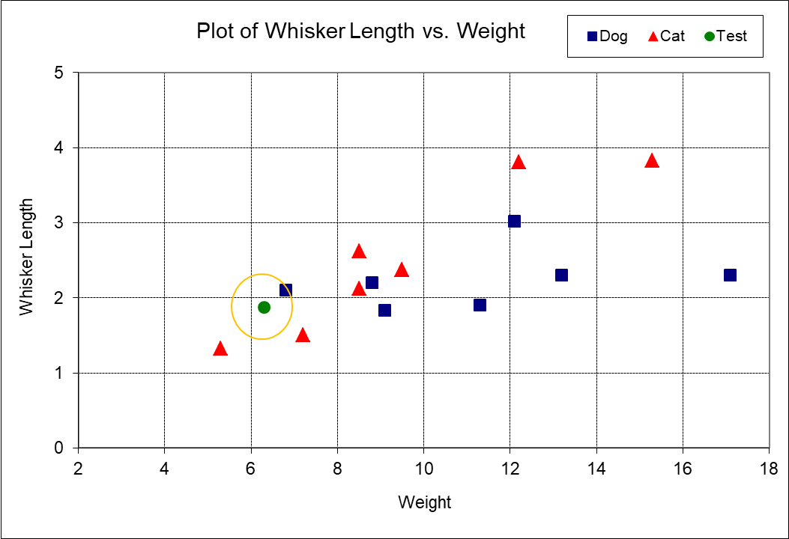

The test point is shown in green in the above plot. In this instance, the nearest neighbor is a dog, so for k=1, the algorithm predicts this test case is also a dog.
For k=3, we widen the circle until it contains the three closest neighbors. Looking back at the plot, you will see that the next two nearest neighbors are both red triangles, meaning cats. The vote is now two cats versus one dog. The majority carries the day, so the green point is now predicted to be a cat! Thus, different values of k can yield different class forecasts for the same test animal.

Generally, we use odd-values of k to avoid ties. If we do use even-numbered values of k and we get a tied vote, then the algorithm orders the software to “flip a coin” to predict the classification! This will produce a kind of “noisy” behavior which we will examine later.
That behavior is surprising, but it is a cheerful thought once one becomes accustomed to it. It is cheerful in two ways. First, it reminds of the fact that we have chosen to use an algorithm which is required to chose “cat” or “dog,” so “tied vote” is not a permissible result. Second, this reminds us that the common notion that forecasts “should” be correct is nonsense.
An important additional fact is this: suppose we get two animals that are equally distant? The simplest way to have that happen is if the two animals have both coordinates the same, but it could also happen just by being equally distant yet at a different location. This case can and will trigger strange performance by the knn algorithm; it can create ties in the voting even when k is odd.

How do we evaluate the performance of a classification method? We can no longer use the MSFE criterion which had we used for numeric forecasts of stock returns. For classification comparison, we use the correct classification rate, or its opposite, the incorrect classification rate.
In terms of deciding what value of k to use, we could use a “leave out one-at-a-time” method. We start by leaving out the first animal of the 15. We run the algorithm for each level of k using the remaining 14 animals as the training set. We record whether the forecast is incorrect or not for each level of k .
We go to the second animal and repeat that process. When we are finished, we have 15 forecasts for each level of k. We compute the proportion of correct forecasts for each level of k. We pick as our preferred k that which yields the highest correct classification rate.
That routine is built-into the k-nearest neighbors R program we will use. In statistical regression, the leave-out-one-at-a-time methodology is used to produce the PRESS statistic.

There is another level to the modern approach. We first split our data into a Training set and a Test set. We set aside the Test data. We decide our value of k based on the Training data.
Then, we take that preferred value of k and try to forecast each member of the Test set. We compare the forecasts against the actual animal type for each animal, and compute the correct classification rate.
This an example of out-of-sample validation. The use of out-of-sample validation moves data mining algorithms and statistical models from the playground to the realm of genuine science. It has also revolutionized our understanding of what real goals are, which are in general not to select the “ideal” value of k, the “right” value of k. Rather, to pick the value of k which performs best on fresh data! Those two goals are quite different.

The k-NN algorithm is a very flexible, non-linear method. As we try different values of k, we give k-NN the opportunity to contort itself to fit to the sample. The non-linearity is good if the underlying reality is complex.
Here is what is meant by an underlying reality. Imagine that we plotted thousands and thousands of cats and dogs in that Weight versus Whisker Length room. Suppose we then found that in local regions there were concentrations of dogs, and then just a little bit away, a concentration of cats. Polka-dotted, local concentrations of animals of the same type would be an example of a non-linear, complex underlying reality.
The k-NN algorithm, given enough data, can reveal and exploit local regions like those. It is a champion in that world!

Section 2: Running k-NN in the Class Package of R

The basic R installation contains the package Class, short for “Classification,” which contains numerous classification routines, including a k-NN function named knn. To open the Class package, simply use the command >library(class).
I am expanding the original dog and cat data with 10 more rows of Test data. I will refer to the initial 15 rows either as the training data or the Train data. The complete data is below, in a form that can readily copied and pasted into Excel.

Index | Weight | Whisker | Class | Study
1 | 12.1 | 3.02 | Dog | Train
2 | 7.2 | 1.50 | Cat | Train
3 | 6.8 | 2.10 | Dog | Train
4 | 12.2 | 3.81 | Cat | Train
5 | 13.2 | 2.30 | Dog | Train
6 | 11.3 | 1.90 | Dog | Train
7 | 15.3 | 3.83 | Cat | Train
8 | 5.3 | 1.33 | Cat | Train
9 | 8.5 | 2.13 | Cat | Train
10 | 9.5 | 2.38 | Cat | Train
11 | 8.8 | 2.20 | Dog | Train
12 | 9.1 | 1.83 | Dog | Train
13 | 8.5 | 2.63 | Cat | Train
14 | 9.5 | 2.38 | Cat | Train
15 | 17.1 | 2.30 | Dog | Train
16 | 14.6 | 1.2 | Dog | Test
17 | 12.8 | 3.2 | Cat | Test
18 | 7.9 | 1.975 | Cat | Test
19 | 8.9 | 2.125 | Cat | Test
20 | 9.9 | 3.175 | Cat | Test
21 | 8.1 | 1.7 | Dog | Test
22 | 9.2 | 1.4 | Dog | Test
23 | 8.6 | 2.45 | Cat | Test
24 | 6.3 | 1.88 | Cat | Test
25 | 15 | 1.5 | Dog | Test

Getting the Pieces of the Puzzle in Order

Create a CSV file with the 25 cats and dogs and read it into R, with the name Dogs. Let’s take a minute to play around with R commands to extract portions of a matrix. For example, what will be produced by the following command?

> Dogs[2, 4]

Now, try
> Dogs[1:5, 3]

And,
> Dogs[1:15, 2:3]

Following the convention adopted by the ISL text, let TrainX denote the coordinates of the animals that will be used to teach the algorithm. Thus, TrainX will consist of the (weight, whisker) measurements for first fifteen animals. We get that as Dogs[1:15, 2:3]. So, in R, write

TrainX = Dogs[1:15, 2:3].

Before going on, type
TrainX
as a command in R and make sure it contains the right items by comparing it to the desired portion of the Dogs matrix.
Now, stop for a minute and consider the needs of the knn function. It wants the following inputs, in this order:
(1) TrainX,
(2) TestX,
(3) TrainY,
(4) k.
Now, you have TrainX, the first argument to knn. Now, try to figure out what TestX, the second argument, should be before you read on. Remember why it is called “Test” and why it has “X” appended to it. Take a few deep breaths, have a sip of coffee, and think about it again. Remain relaxed because you are free at any time to go to the next page, where you will find my commands and the output. Take a peek and see how you are doing.
Do the same for TrainY. What does that name denote? Why “Train” and why “Y”.
When your pieces match mine, set k=3 and run the knn function. The ISL text uses knn.pred as the name of the Yhat output, so we will use that name, too. So, your command will look like this, but remember to open the package with > library(class), first:
> knn.pred = knn( TrainX, TestX, TrainY, 3)

Type knn.pred and check your output to mine.

After getting the predictions, we need to compare those against the available actual animal types available for the test data. The function we use is called table in R. Its usage is shown below, but you need to play around with it to understand it. The value of 4 in [1,1] position says of the 10 Test animals that 4 of the times when Cat was predicted (a row event), the animal was a Cat. The 1 entry says that one Cat forecast turned out to be in reality a Dog.
As shown, the correct classification rate was 0.7 on a sample of 10 test cases.
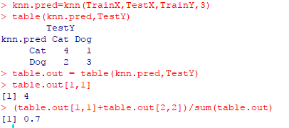
Section 3. Notation for Forecasting

In math, science, and data mining, it is common to use the following notation. Grasping this notation is important in the long run, but it is not vital to nail it down right now. Just take a hack at it; that is what matters right now. In the long run, learning to work with symbols of this kind will leverage your understanding. Be assured, though, that you don’t need to follow this notation to make use of the techniques I am going to show you for handling the knn input steps. If your head starts to spin, immediately skip to the top of page 10. Then, on the next day, go back and give it another try. You will be surprised by how the unreadable becomes clear after a good night’s sleep.
We wish to forecast a variable named Y. When using KNN, the Y variable is a class variable. Here, think of Y as “Animal Type”, being either Cat or Dog.
With that notation, we could reference the Y variable in row #18 as Y₁₈.
In this case, we see that
Y₁₈ = Cat.
However, remember that this does not mean that every animal with the same weight and whisker length as cat in row 18 animal will always be a cat! Likewise, flipping a coin and getting Heads does not demonstrate that we will get Heads when we flip a second time. Thus, you will be wise to keep in mind that the concepts and notation we are using are considerably more complex and subtle then what you used in High School. Our Y variable is an example of a “random variable,” and the values we observed it take are not necessarily more fixed than is a coin that happened to land on Heads.
Our forecasting function, f, takes an argument denoted X. Usually, X will contain multiple values. Here, X contains two numeric values: Weight and Whisker:
X = (Weight, Whisker).
For row #18, then, we have
X₁₈=(Weight=7.9, Whisker=19.75).
Now, we take our forecast function, f, and feed in the argument X. The function provides us with a value denoted Yhat,
Yhat = f (X).
More specifically, for row #18, we have
Yhat₁₈ = f (X₁₈) = f (7.9, 19.75)
Naturally, you would like me to tell you the value of Yhat₁₈, but I cannot because have not yet run the algorithm! We have not yet created our forecast function, f. More exactly, we have not yet estimated our forecast function. Part of estimating that function will involve trying different values of k, where k is the size of the neighborhood! You will see in the text ISL that the authors frequently refer to the forecast function as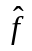, to remind us that this is not quite like the functions you encountered in high school. Also, there is a second sense in which we are estimating f : if we took a different set of 15 cats and small dogs, we would get a different estimate of f, meaning that we almost certainly get different forecasts than were produced from the original sample.
Section 4. A Stock Market Application
The ISL textbook (4th Printing) has some material on k-NN starting on page 39. Also, Figure 2.1.4, on page 4, is worth looking at if you have absorbed the similar picture in Section 1 of this document.

The DATA
The serious introduction to k-NN start at the bottom of page 163, with an application to stock return data! I am going to walk you through what was done. The data that was used was daily returns on the S&P500 Index from the start of 2001 to the end of 2005. In ISL, this data set is called SMARKET.
The data was broken into a training data set of daily returns from 2001 to the end of 2004, and a testing set of the 2005 daily returns. SMARKET should be downloadable from Stanford University, but I was not able to access it. I think the site has not been updated in years. Therefore, I went to Yahoo Finance and created my own version, which I named SMarketTatum. This has been posted to Blackboard as a CSV file. It is probably a little different, if only because it was unclear if ISL SMARKET starts the download at January 1, 2001, or if it started five trading days earlier.
That data set contains columns named Lag1, Lag2, up to Lag5, in parallel with SMARKET.
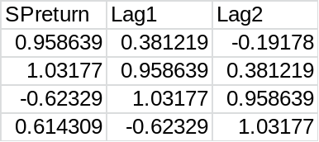
What does Lag1 do? In the Excel file, notice that in the SMarketTatum worksheet that the data now starts on January 10th instead of January 2nd. This allows me to start trying to forecast the daily return on January 10th using the daily returns for earlier days in January. The Lag1 column has the previous day’s return, the Lag2 has the return from two days earlier, and so on. Thus, in the third row, second column, the Lag1 value 1.02177, which is the previous day’s return in column 1. Likewise, in the third row, third column, we have the Lag2 value of 0.958639, which is the return from two days before in the first column.

In order to use a classification program, we need to have a class to predict, like dog or cat. Here, we will use Up and Down. Up means that the SPreturn was positive, Down means it was negative. That column was created in Excel and is included in SMarketTatum, just as it was in SMARKET from ISL.

The KNN PROGRAM

Step 1:
>library(class)

We are going to use the knn function within the class package.
For now, I am just going to show you the steps needed to follow along with IML, collected together in one place, which will get us results similar to what are shown in IML for this application of KNN. Later, we go back and learn how it is structured.
Reading-in SMarketTatum

Step 2: Input the csv file. Warning – I had to re-type the quotation marks within R when I initially copied and pasted this command, Times Roman font does not give quotation marks that are recognized by R:

SMarketTatum <- read.csv (“C:\\Documents and Settings\\Administrator\\Desktop\\SMarketTatum.CSV”)

This is what it looked like in R after overwriting the quotation marks, and it worked:

SMarketTatum <- read.csv ("C:\\Documents and Settings\\Administrator\\Desktop\\SMarketTatum.CSV")

You may also be able to read it in with the simpler command,
SMarketTatum <- read.csv ("SMarketTatum.CSV") (careful about CSV versus csv)
but remember that only works if the default location in which R looks is the Desktop and you have put your file on the Desktop!

I regret to say that I have encountered numerous instances where Word text pasted in R results in extra spaces being added to the text. These spaces prevent R from recognizing the commands. So, always check pasted commands which fail to run – it may be something very small that is wrong.
A student has correctly observed that if we use a simple text editor, like Microsoft’s WordPad, we will not have these problems. But, giving-up on Microsoft Word has its own downside.
An alternative is to try typing commands directly in to R rather than pasting them. But, a single error may have appalling consequences and be hard to locate. Lesson: stay alert. We all hope that someone else will locate our typing errors or strange artifacts introduced by pasting from Word, but that is seldom true.

Defining the Variables as in ISL and Running the knn Program
Step 2: I am going to do this in just way it is done in ISL, but I believe it could be done more simply. First, I will show the commands as copied from R into Word, then a screenshot.
> SMarketTatum <- read.csv ("C:\\Documents and Settings\\Administrator\\Desktop\\SMarketTatum.CSV")
> Lag1 <- SMarketTatum$Lag1
> Lag2 <- SMarketTatum$Lag2
> Year <- SMarketTatum$Year
> train = (Year < 2005)
> SMarketTatum.2005 = SMarketTatum[!train,]
> Direction <- SMarketTatum$Direction
> Direction.2005 = Direction[!train]
> train.X=cbind(Lag1 ,Lag2)[train ,]
> test.X=cbind (Lag1 ,Lag2)[!train ,]
> train.Direction =Direction [train]
> knn.pred=knn(train.X,test.X,train.Direction,k=1)
> table(knn.pred,Direction.2005)
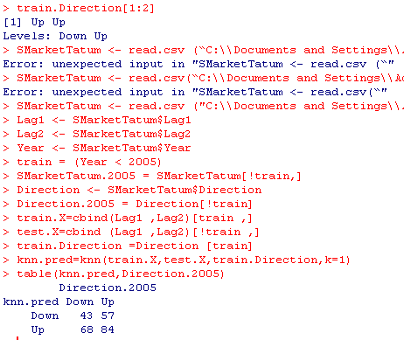

Computing the Rate of Correct Forecasts

Step 3: The 2x2 table at the bottom of the preceding screenshot tells us how well the forecasts worked. Let me show an expanded version of the table that may help you.

Two by Two Table of Forecast versus Actual
 | Actual
Forecast | Down | Up | Total
Down | 43 | 57 | 100
Up | 68 | 84 | 152
Total | 111 | 141 | 252

Start by looking down the Forecast column to the Down entry. Look across that row to the Total column, with an entry of 100. This means that the knn algorithm produced a total of 100 Down forecasts. Of those, 43 were correct and 57 were wrong. Using (forecast, actual) notation, there were 43 instances of (Down, Down) and 57 instances of (Down, Up). For the 152 Up forecasts, there were 68 (Up, Down) instances and 84 (Up, Up). The total number of correct forecasts was (43+84). The total number of forecasts was (43+57+68+84), so the rate of correct forecasts was
(84+43) / (84+43+68+57)
which is very close to 0.5, as noted in ISL. R will compute that for us,

> p <- (84+43) / (84+43+68+57)
> p
[1] 0.5039683

I would not be surprised if we could beat that by simply forecasting Up for every day! In fact, with the Totals conveniently waiting above, we can immediately see that the proportion of actual Up days was 141/250. Take a minute and see where those values came from. That is a proportion of 55.9%. So, a thinking question: What would be the rate of correct forecasts if we had always forecast Up? That seems unfair, but it is a legitimate thought. What that means is that k=1 knn forecast method did not do well at all because it could not even beat a ridiculously simple forecasting method.
Later on, in the ISL text, the authors note that a “neural net” method – a very sophisticated technique – arrives at a forecast very much like that one because the algorithm finds it cannot beat simply forecasting the most common class, 100% of the time!

Trying a different value of k
Step 4: Now that we have done all the hard work, which was preparing the data and getting the class package operating, it is easy to run knn for other values of k, for example, k=3, as is done in ISL.

> knn.pred=knn(train.X,test.X,train.Direction,k=3)
> table(knn.pred,Direction.2005)
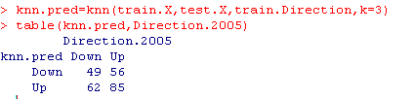

As noted in ISL, there is a small improvement in performance, but nothing to brag about. But, I’ll bet we can easily get interesting results with the daily range. As we have noted, the level of risk (or volatility) in the market has momentum, so lags of range would have predictive power.
We could also readily write a little loop program to run through many values of k for the knn program. But, instead of spitting out the MSFE values, we could figure out how to output the rate of correct forecasts.
It remains to be explained how the knn program is making use of the training and testing data sets. It is not obvious, but the program is set up in a highly ethical fashion!

Section 5. Application to Forecasting Risk
Here is a series of commands I used to read in IBM range data with Lag1 and Lag2 values, assign HighRisk and LowRisk Y values, shuffle and split the data into a training and testing set, use the knn to predict the risk level, and compute the correct classification rate of 69.7%, a very nice rate!
Please note the insertion of the “as.factor” transformation that converts my Y values to data type factor. That will be needed in LN5.
On the next page is screenshots, on the second page is text version using Courier font, which often provides better alignment of copied computer output than any other font. Those commands can be directly copied and pasted, but don’t bring the > symbol.

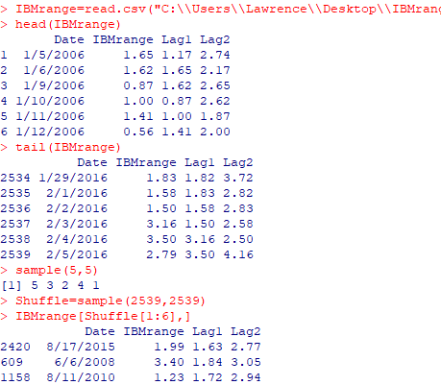

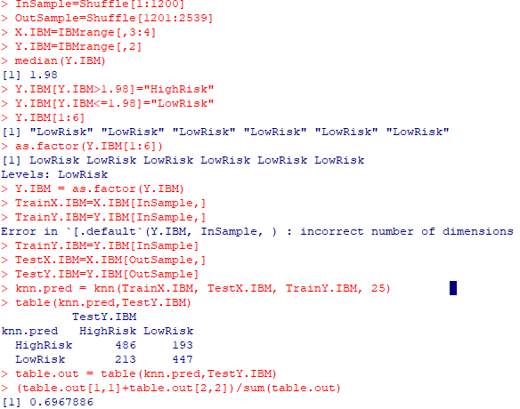

> IBMrange=read.csv("C:\\Users\\Lawrence\\Desktop\\IBMrange.csv")
> head(IBMrange)
Date IBMrange Lag1 Lag2
1 1/5/2006 1.65 1.17 2.74
2 1/6/2006 1.62 1.65 2.17
3 1/9/2006 0.87 1.62 2.65
4 1/10/2006 1.00 0.87 2.62
5 1/11/2006 1.41 1.00 1.87
6 1/12/2006 0.56 1.41 2.00
> tail(IBMrange)
Date IBMrange Lag1 Lag2
2534 1/29/2016 1.83 1.82 3.72
2535 2/1/2016 1.58 1.83 2.82
2536 2/2/2016 1.50 1.58 2.83
2537 2/3/2016 3.16 1.50 2.58
2538 2/4/2016 3.50 3.16 2.50
2539 2/5/2016 2.79 3.50 4.16
> sample(5,5)
[1] 5 3 2 4 1
> Shuffle=sample(2539,2539)
> IBMrange[Shuffle[1:6],]
Date IBMrange Lag1 Lag2
2420 8/17/2015 1.99 1.63 2.77
609 6/6/2008 3.40 1.84 3.05
1158 8/11/2010 1.23 1.72 2.94
2015 1/7/2014 3.97 2.06 3.05
239 12/14/2006 1.18 0.83 2.55
719 11/11/2008 4.04 5.36 3.46
> InSample=Shuffle[1:1200]
> OutSample=Shuffle[1201:2539]
> X.IBM=IBMrange[,3:4]
> Y.IBM=IBMrange[,2]
> median(Y.IBM)
[1] 1.98
> Y.IBM[Y.IBM>1.98]="HighRisk"
> Y.IBM[Y.IBM<=1.98]="LowRisk"
> Y.IBM[1:6]
[1] "LowRisk" "LowRisk" "LowRisk" "LowRisk" "LowRisk" "LowRisk"
> as.factor(Y.IBM[1:6])
[1] LowRisk LowRisk LowRisk LowRisk LowRisk LowRisk
Levels: LowRisk
> Y.IBM = as.factor(Y.IBM)
> TrainX.IBM=X.IBM[InSample,]
> TrainY.IBM=Y.IBM[InSample,]
Error in `[.default`(Y.IBM, InSample, ) : incorrect number of dimensions
> TrainY.IBM=Y.IBM[InSample]
> TestX.IBM=X.IBM[OutSample,]
> TestY.IBM=Y.IBM[OutSample]
> knn.pred = knn(TrainX.IBM, TestX.IBM, TrainY.IBM, 25)
> table(knn.pred,TestY.IBM)
TestY.IBM
knn.pred HighRisk LowRisk
HighRisk 486 193
LowRisk 213 447
> table.out = table(knn.pred,TestY.IBM)
> (table.out[1,1]+table.out[2,2])/sum(table.out)
[1] 0.6967886

Lecture Notes 4. Exercises

4.1 Starting with the 25 cats and dogs, walk through the steps done in the lecture notes, showing your work. Those values are in the accompanying R file under the name Dogs. Don’t copy and paste my commands. Rather type in all commands yourself and think about what the commands are you doing. That will help you learn them because you will likely have to make many corrections to your typing!

4.2 Employing the methods used with the stock market data in ISL and this lecture note, explore using knn with lagged daily return values of your stock data. The authors split the daily return in Up and Down, above or below zero. Like the authors, you will be unable to get a correct forecast rate much different from 50%. That is because the stock market is highly efficient. You find that disappointing, but it is no single fact about the stock market that is more important to know than that!

4.3 As shown in Section 5, try using the lagged daily range to forecast the range, where
range = High-Low.
Split your y-variable range into HighRisk and LowRisk according to whether or not the value is above the median or below. I suggest creating the lags in Excel. Forecasting risk tends to work fairly well in this setting, with a correct forecast rate in my experience of above 60%. In the example in Section 5, I only used Lag1 and Lag2, but you are welcome to use more lags – it takes only a little more work!

Be sure to explain what you are doing in this section: you have to be able to explain it very carefully to yourself in order to ever hope to be able to explain it someone else! I have explained nothing about my code in Section 5, but that is on purpose! You need to learn to explain it to yourself, then you can explain it to the reader.

